**Insights:**

**FOR MARKETING ANALYSIS:**

1. **Loyal User Award:**

**In this, the five loyal and oldest users of the app are found. It can be used to target them for exclusive loyalty programs.**

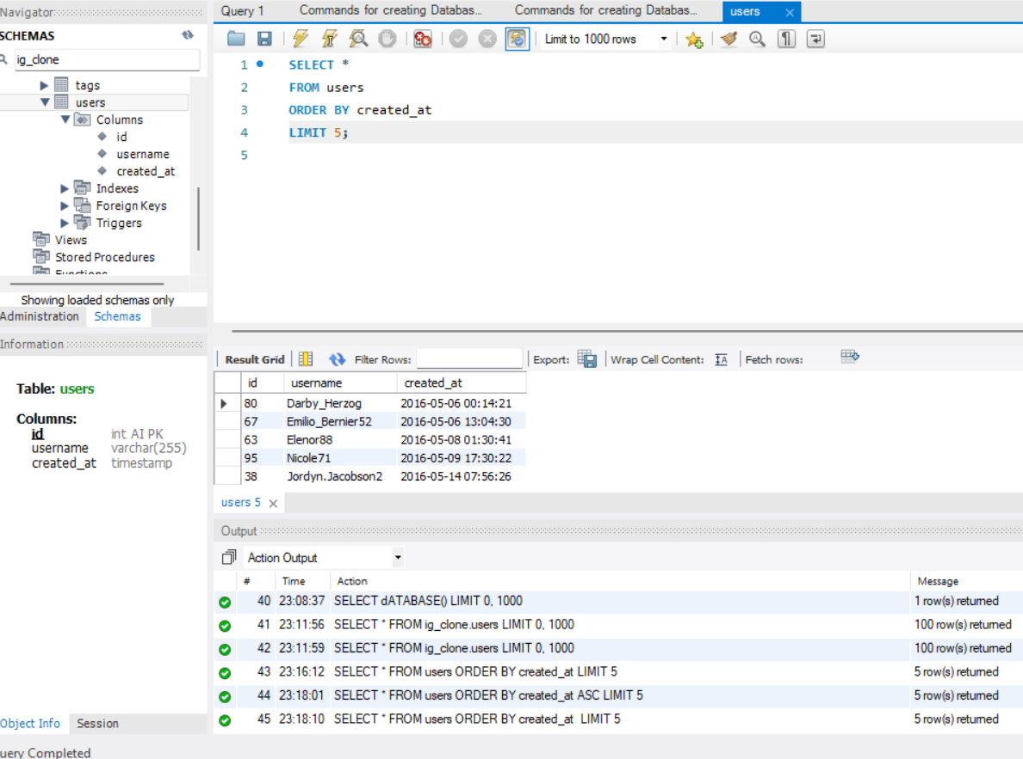

**In this, all the tables from the users are selected and the data compiling ID, username, and date and time of creation are ordered. The limit is set to 5 thus accumulating five loyal users.**

1. **Inactive User Engagement:**

**To know about the users who have never posted any posts found. This data will be further used to send them promotional emails so that they are encouraged to post thus increasing the platform’s growth.**

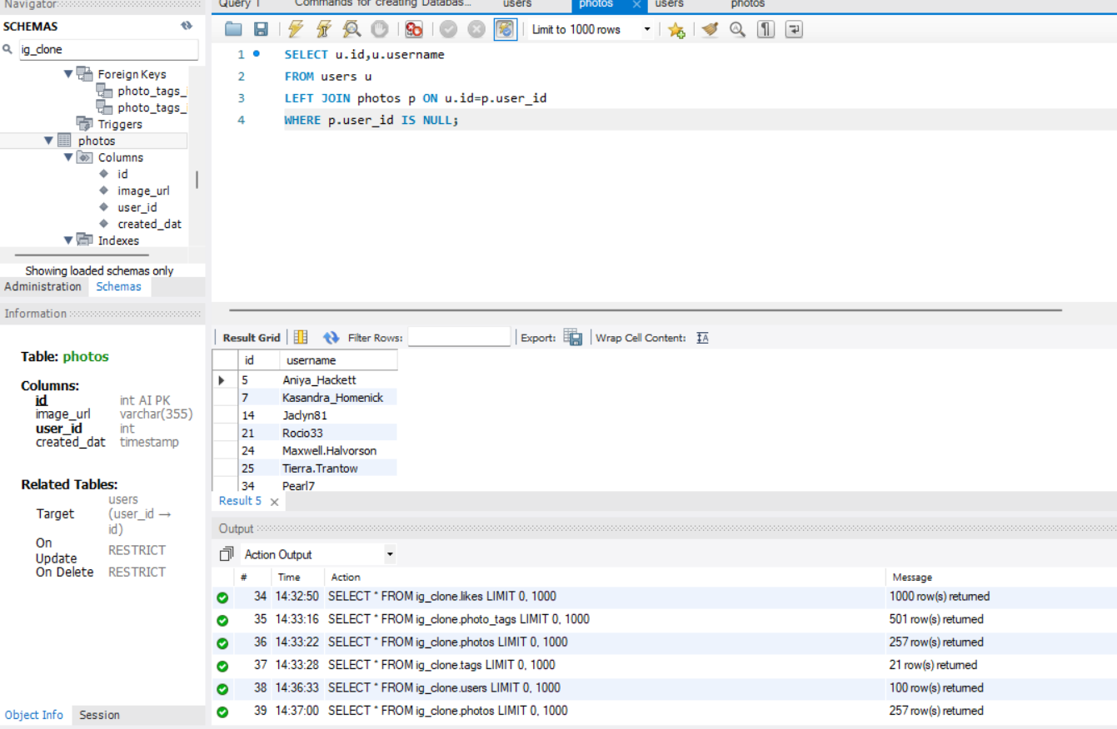

**In this, from the users' table, the id and username columns are selected, then the id column of users and the user_id column of photos are left joined so that the user_id with no posts is identified.**

1. **Contest Winner Declaration:**

**In this, that user would be identified who will have the most likes on their post so that they are rewarded. It will help motivate and influence the community thus increasing engagement.**

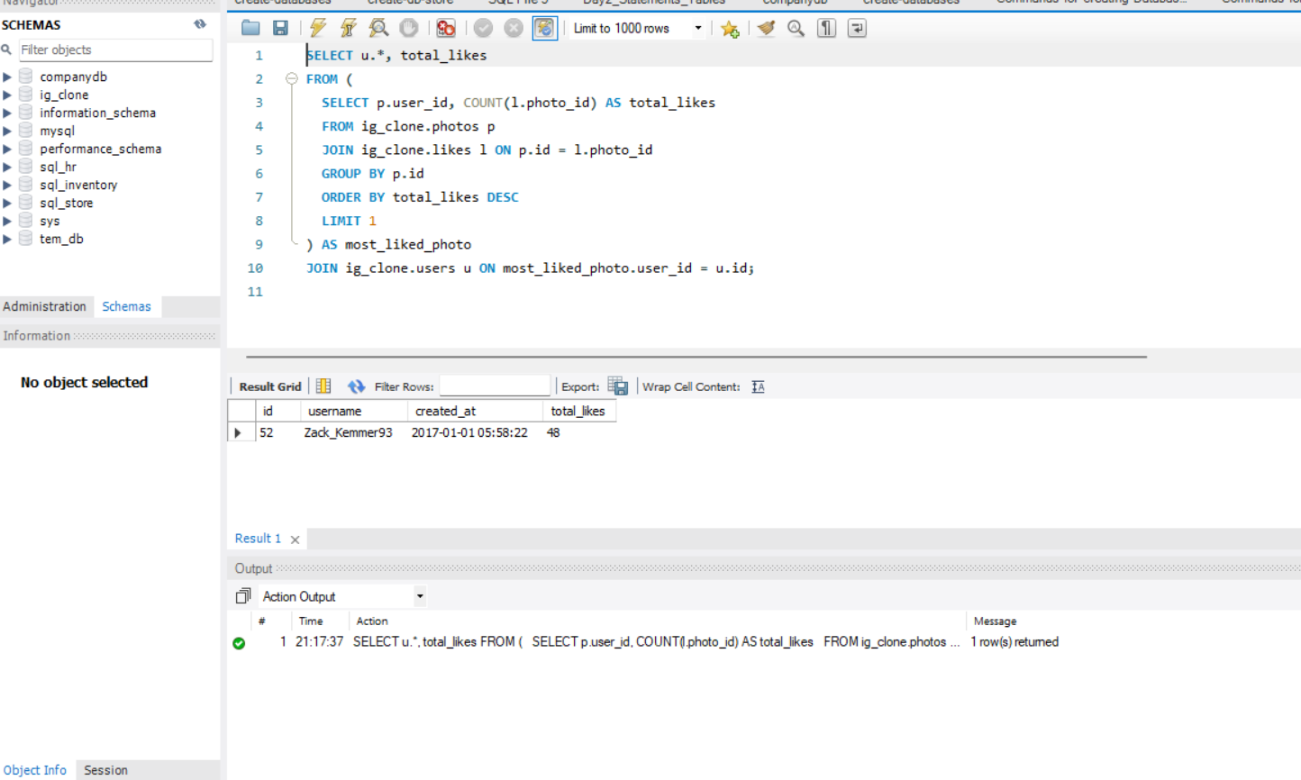

**In this, the inner query selects user_id and photo_id from the photos table thus counting likes received. Later on, it groups the result by a number of likes and LIMIT 1 assures only one is chosen. The outer query joins the result of an inner query and selects all columns from the user's table and the total_likes column.**

1. **Hashtag Research:**

**In this, the five most popular hashtags are revealed. This data will help the brands and marketing team to launch certain campaigns thus increasing their reach.**

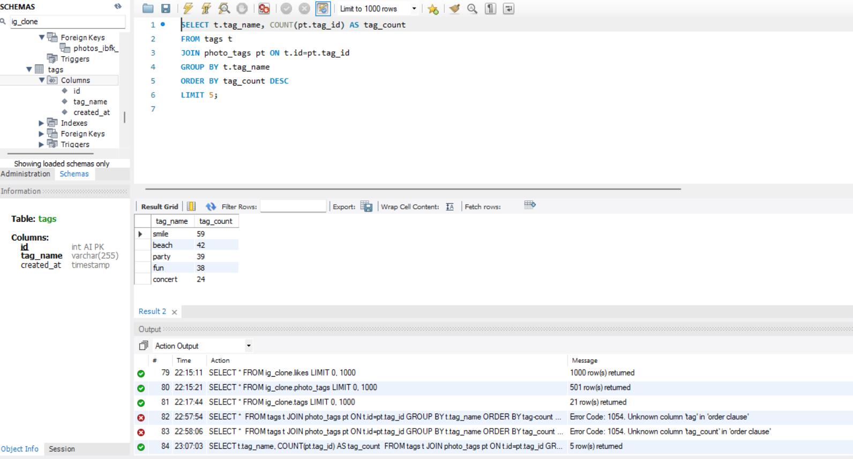

**In this, the tags column is selected, in which its tables consisting tag_name and tag_id is selected. The tag_count is used to count the number of occurrences appearing in the table. Then the results are grouped by tag_name and are ordered by tag_count in descending order keeping its limit five. Thus we have the five most popular hashtags.**

1. **Ad Campaign Launch:**

**In this, the user’s registration data is extracted to know about the days with the maximum number of registrations. It helps in scheduling ad campaigns increasing its visibility and effectiveness.**

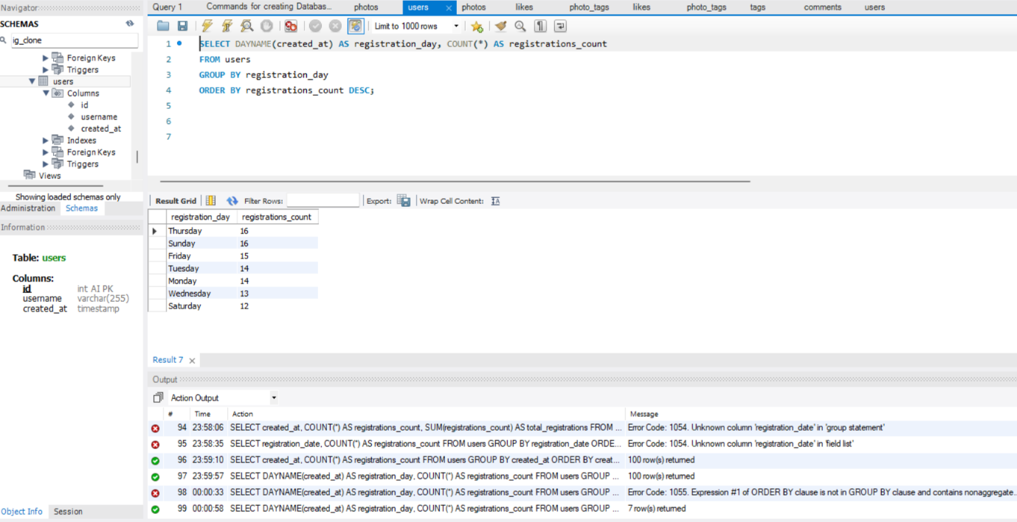

**In this, from users column created_at is aliased as registration_day thus getting the days, then the results are counted and grouped by registration_day. Finally it is ordered by registration_count in descending order thus getting day of the week when users register the most.**

**FOR INVESTOR METRICS:**

1. **For User Engagement:**

**To encourage healthy engagement this data of average posts per user is extracted where the total number of posts and total number of users are also found. It helps in further accumulation of knowledge about users' activity and involvement on the app.**

**Total number of Photos:**

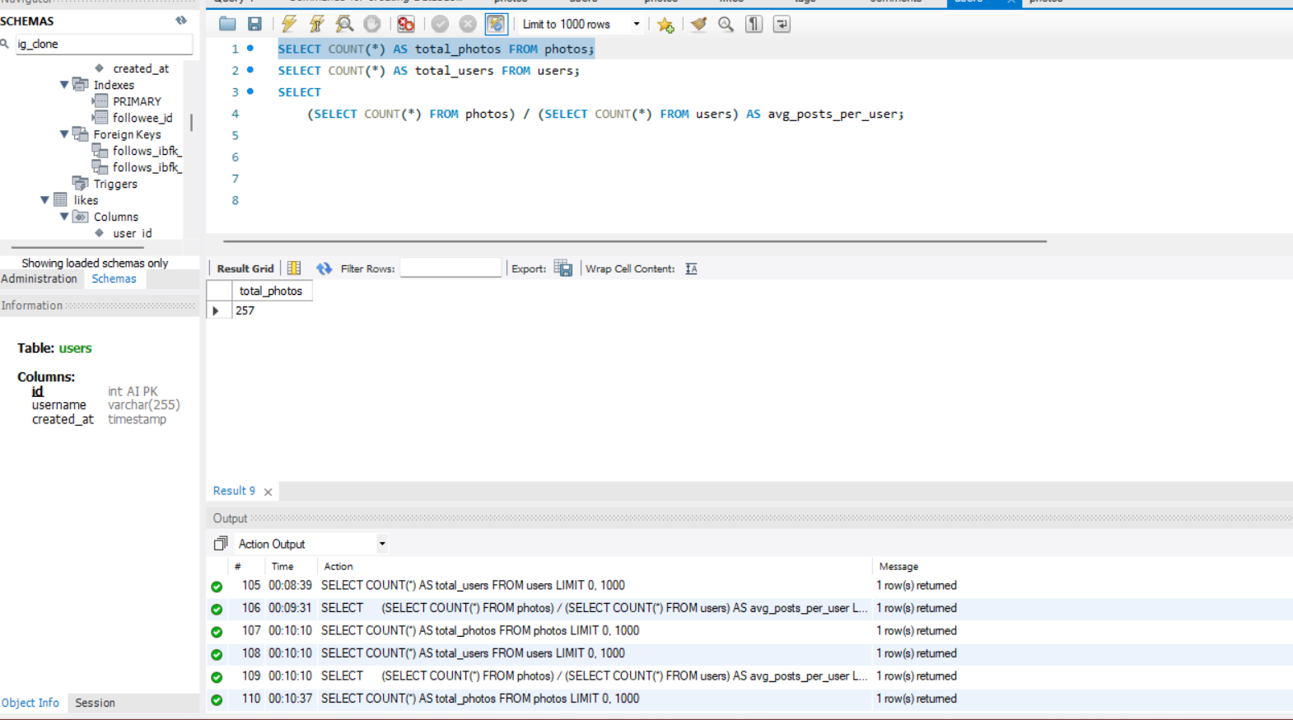

**Total number of users:**

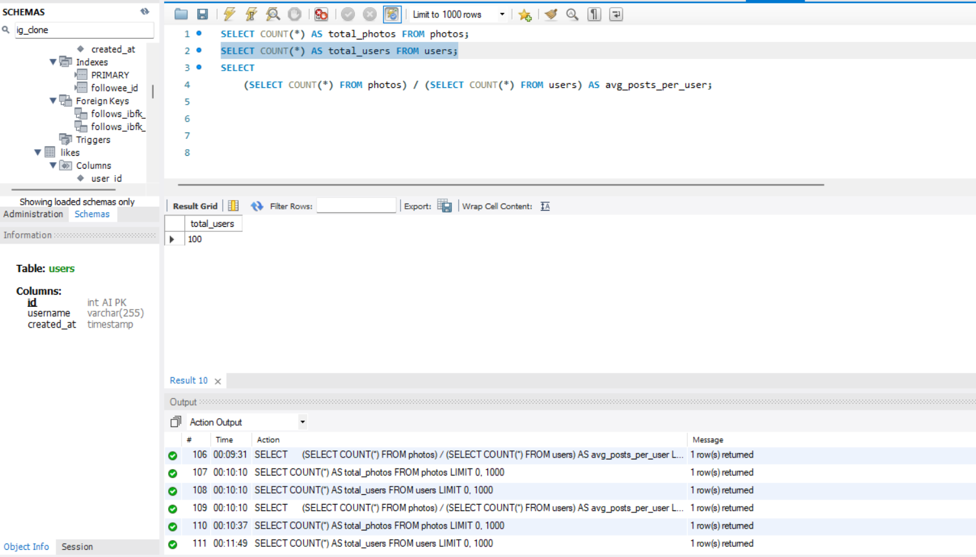

**Now average posts per user:**

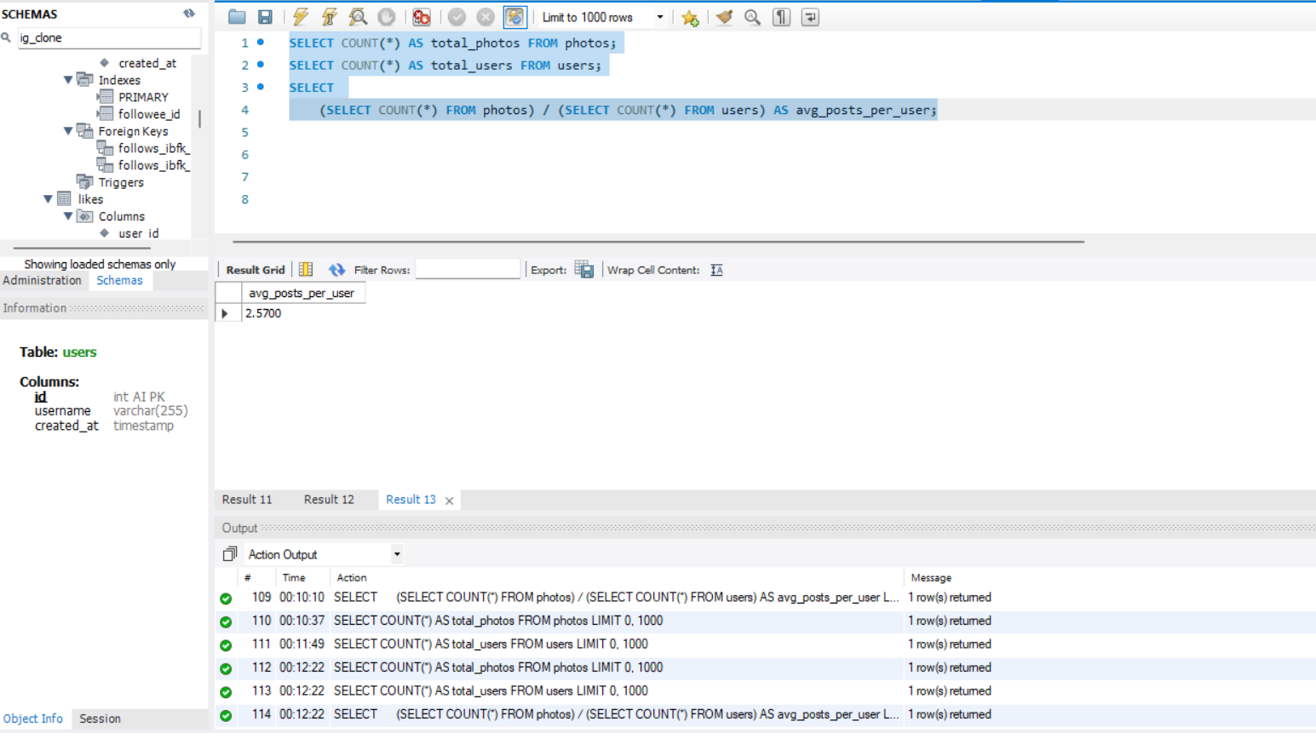

**In this, the subquery helps in finding the number of posts from the photos table similar with the user's table to get a number of users and the result is grouped to get the count. Then with the help of an outer query, the average number of posts is calculated.**

1. **For Bots and Fake Accounts:**

**In this, the accounts is termed as bot account which has liked every post that is impossible for regular account. So that account is to be found and then eliminated to improve platform’s credibility and user’s experience.**

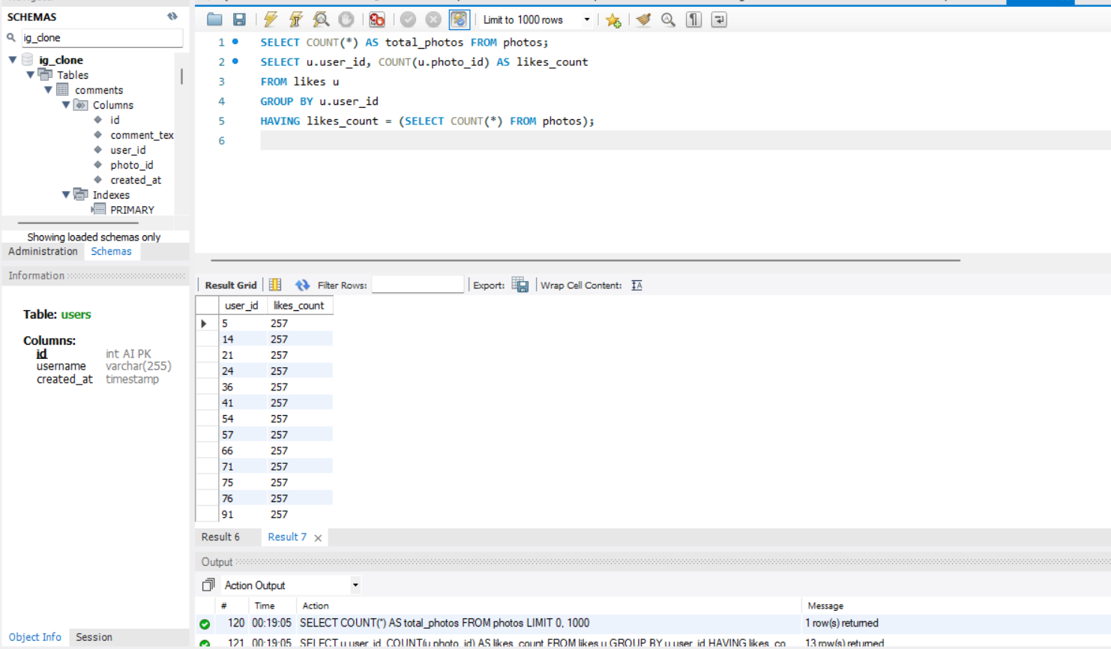

**In this, from the photos table, all columns are selected and termed as total_photos then from the likes table user_id, and photo_id are selected. The former is termed as likes_count and the total number of photos is counted. Then it is grouped by user_id and the Having clause helps in filtering out users whose count is equal to the total number of photos on the site. Thus, the potential bots are identified.**

**Results:**

**Achievements:**

1. **I got to know how and what strategy should be taken so that inactive users are identified.**
2. **I also got to work on knowing how loyal users are identified and can also identify potential bot accounts.**
3. **The hashtags are identified for better marketing strategy, and the best days for marketing campaigns are also found.**
4. **A deeper analysis of Likes’ data is analysed helping in declaring the contest’s winners.**
5. **Lastly to handle the user engagement metrics the average number of posts per user is calculated to know more about user activity levels.**

**Insights gained:**

1. **With the help of this project I gained deeper insights into user’s behaviour on social media apps, and how the users’ data is used to improve engagement on the app.**
2. **I also got to know how to derive useful data for marketing and development teams, and investors thus ultimately helping in the platform’s growth.**
3. **Last but not least it also helped me gain profound skills in SQL, how to work with MYSQL workbench software, and how to clean and prepare the data. This all helped me build my skills in data analysis.**